**Социальная реклама в области энергосбережения**

**[](http://gutovo.toguchin.org/wp-content/uploads/2014/02/э5.jpg)**

[](http://gutovo.toguchin.org/wp-content/uploads/2014/02/э6.jpg)

[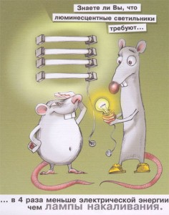](http://gutovo.toguchin.org/wp-content/uploads/2014/02/э4.jpg)

[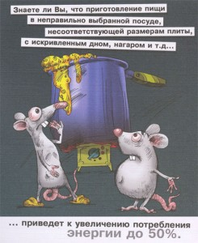](http://gutovo.toguchin.org/wp-content/uploads/2014/02/э3.jpg)

[](http://gutovo.toguchin.org/wp-content/uploads/2014/02/э1.jpg)